CI.a-k - The chemical industry | CI1-6 |

CI.Q Exam questions from past papers
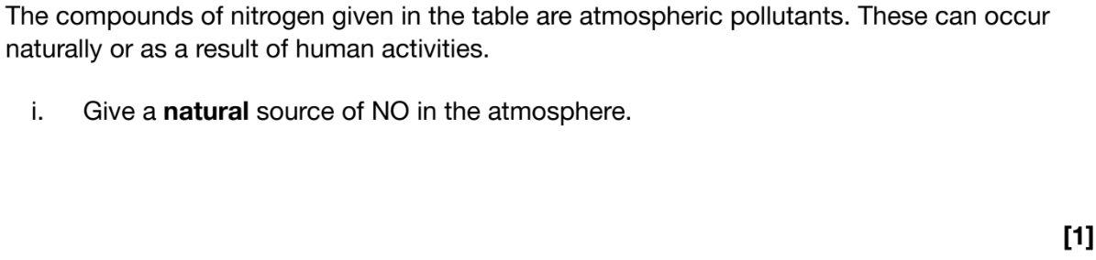  Give a natural source of NO in the atmosphere? | 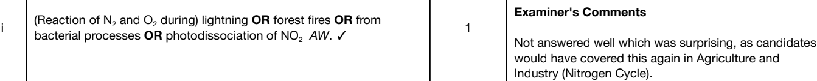  - Lightning  - Forest fires  - From bacterial processes  - Photodissociation of NO₂
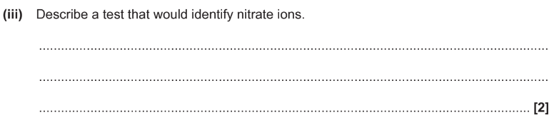  Describe a test that would identity nitrate ions (2) | 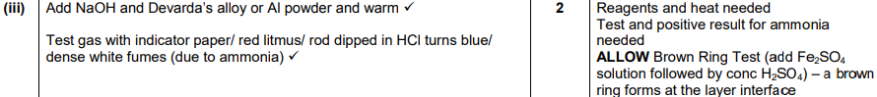  - Add NaOH solution and devarda’s alloy (or Aluminium foil)  - Warm the solution  - Test gas with red litmus paper and would turn blue if ammonia is present  - [as the Al in both would reduce the nitrate ions]  (You would see dense white fumes due to ammonia)  Allow use rod dipped in HCl turns blue  Allow Brown Ring Test (add Fe₂SO₄ solution followed by conc H₂SO₄ ) - a brown ring forms at the layer interface
Some students set out to investigate the rate of hydrolysis of 1-bromobutane. They mix 1-bromobutane with sodium hydroxide solution and measure the conc of hydroxide ions after certain times at 51 degrees?  Suggest the procedure the students use to follow the reaction? (3)  How did they maintain the temperature at 51 degrees (1) | - Quench the solution taking certain volume of solution at set intervals of time (1)  - Cool down the samples in ice water (1)  - Do a titration for each sample to find the concentration of hydroxide ions (1)  - By using a water bath
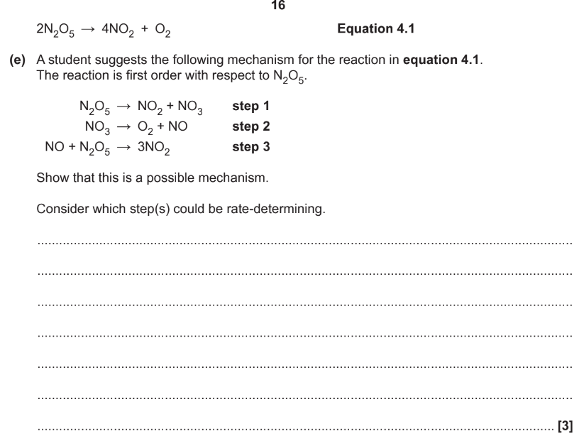  Consider which step is the rate-determining? (3) | 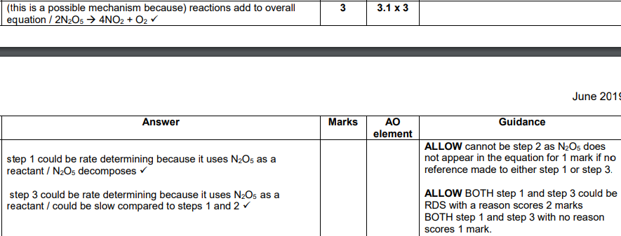  - Reactions add to make overall equation (1)  - Step 1 could be rate determining as it uses N₂O₅ as a reactant (1)  - Step 3 could be rate determining as it uses N₂O₅ as a reactant (1)
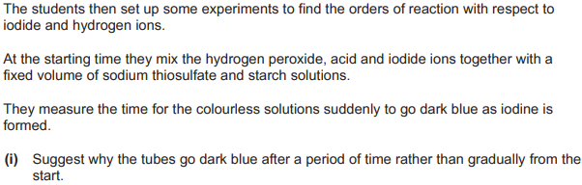  - Suggest why the tubes go dark blue after a period of time rather than gradually from the start. (3)  - How can relative rates of reactions be found from the student’s results? | - Thiosulfate reacts with the iodine until thiosulfate is used up  - Iodine reacts to form blue black colour with starch  - 1/time = rate

CI.a-e - Kinetics | CI3 | CI4 | CI5 |
Define Rate of reaction? | The change in concentration of a substance per unit time  This is used for consistency as it’s better than say change in mass per unit time
Give 6 ways of determining the rate of reactions? | - Use a gas syringe to measure the change in volume of gas  - Use a top pan balance to measure the change in mass as gases escapes (works best with a heavy gas like CO₂)  - Measure the time taken for a precipitate to form (cross method)  - Use colorimetry to measure absorbance of a wavelength by a chemical  - Chemical analysis by quenching and titration  - Do a clock reaction  Also measure a change in electricity conductivity (works well if ions are released)
What are the 3 orders of reaction with their associated rate-concentration and concentration-time graphs of the reactant(s)? | - Zero-order reaction - rate is not changed by concentration  - First-order reaction - rate ∝ conc  - Second-order rate - rate ∝ conc^{x} (by some factor i.e if conc x2 then rate is x4)  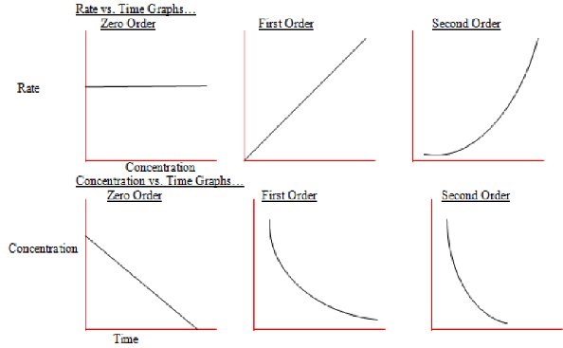  The concentration-time graph of a second-order reaction isn’t required.
Describe the following general rate equation: r =k[A]^{x}[B]^{y} | - Based on the reaction… aA +bB -> products  - Unit of r (rate) is moldm⁻³s⁻¹, unit of [A] and [B] (conc. of A and B) are moldm⁻³, and unit of k (rate constant) varies  - The rate constant is ONLY dependent on temperature (i.e., it increases with temperatures)  - The values x and y are called reaction orders and have nothing to do with the stoichiometric coefficients (moles) in the balanced equations. They are worked out experimentally and can be 0,1 or 2  - The overall order is x + y
What is the half-life of a reaction? And the half-life equation for a first-order reaction? | - The time taken for the conc of a reaction to half (which is constant for a first-order reaction).  - Depending on the question find 3 half lives unless quoted otherwise  - The equation for first order is  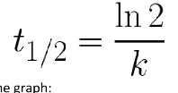--  - Shown on the graph:  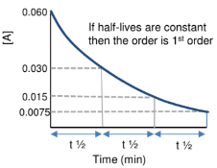  If the half-life rapidly increases then the reaction is second-order. If the half-life decreases then it’s zero-order.
Give 2 ways of determining orders of reaction and state the benefit of one over the other | - Use a clock reaction to get a good approximation of the initial rate  - Then use the initial rates method  - Continually monitor [A] and form a concentration-time graph for many different concentrations then use this to plot a rate-concentration graph whose shape you can use.  The first method is far less time-consuming as a graph doesn’t have to be plotted each time
What 3 assumptions are made during a clock reaction? | - The concentration of reactant doesn’t change significantly over the timescale  - Constant temperature  - When the endpoint is observed, the reaction has not proceeded too far.  This allows us to assume a constant rate
What should be ensured when continually monitoring [A] and why? (in rates of reaction) | Having a large excess of everything else so their conc. Is effectively constant -> its conc won’t change much during the reaction -> won’t affect the reaction
How can you work out reaction orders using experimental initial rate and concentration data? [The script to experimental data rate questions!]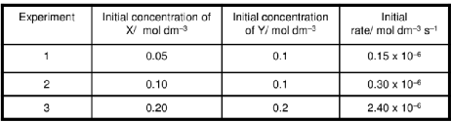 | - You have some equation r =[X]ª[Y]^{b}. Comparing (1) and (2), the order of reaction w.r.t. [X] is 1 (as initial rate doubles when initial conc doubles)  - Comparing (2) and (3), both X and Y double whilst the initial rate increases x8. Know [X] is order 1 so Y doubling increases initial rate x4 -> order 2  Say you have r = k[A][B]². The effect of individual changes in conc are multiplied E.g., if [A] x 2 and [B] x 3 then initial rate x 18
What is the Arrhenius equation both variations, what can it be used to find? | 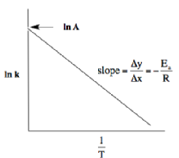  - k=Ae^{-Ea/RT}  - ln k = ln A + -Ea/RT  - k = rate constant (which is proportional to rate)  - E_{a} = activation energy in Jmol⁻¹  - R = gas constant  - T = temperature in K  In the form of y = mx + c  Ln k = (-Ea / R) x (1/T) + ln A  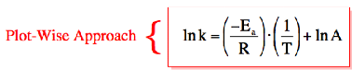  Use to determine the activation energy using a set of temperature and rate constants. Can also be used to determine the frequency factor (A) which would be the y intercept then times it by e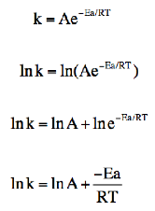
Define Rate Determining Step (RDS)? | The slowest step in a reaction mechanism which determines the overall rate of reaction
What things should you look out for when proposing mechanisms from overall reactions and rate equations? | - A catalyst appearing in the rate equation as it will reform later  - When the slowest step contains an intermediate (not a reactant). It should be replaced by substances that make up the previous step  E.g.,  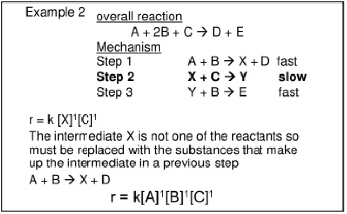  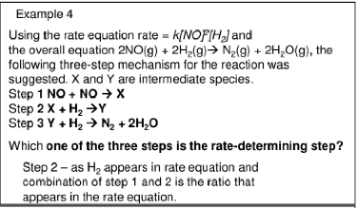  You need both to be able to propose the mechanism
What should you be aware of when suggesting a mechanism via a rate determination step through an example? | - 2N₂O₅ -> 4NO₂ + O₂  - Even though there are 2 moles in the equation, experimentally the reaction is 1st order w.r.t N₂O₅  - Rate = k[N₂O₅]  - This determines there is only 1 mole of N₂O₅ in the RDS  - One possible mechanism is:  - N₂O₅ -> NO₂ + NO₃ - slow step  - NO₃ + N₂O₅ -> 3NO₂ + O₂ - fast  - 1st step is RDS as there is 1 mole of N2O5 and is the only equation with only rate equation reactants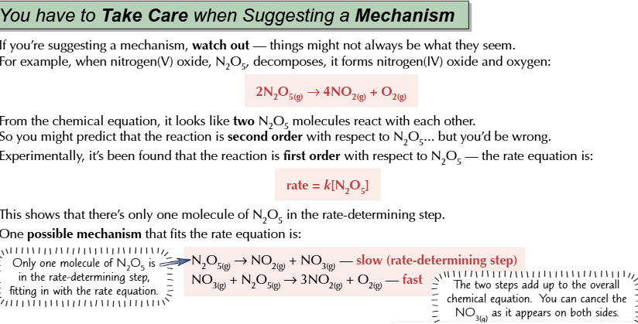
What are 2 things that are always true for the rate determining step? | - Only reactants in the rate equation is involved in RDS  - Order of reaction in rate equation (i.e. moles of reactant) = Moles in RDS

CI.f-h - Equilibrium | CI2 | CI6 |
What compromises must be made when altering the equilibrium position and why? | Pressure:  - A lower pressure when favouring the side with less moles -> high pressures are difficult to produce as high costs (high electrical costs in pumping gas) and is unsafe (difficult to contain high pressures)  - A higher pressure when favouring side with more moles otherwise the rate of reaction will be too low.  Temperature:  - A higher temperature when favouring the exothermic side otherwise the rate of reaction will be too low  - A lower temperature when favouring the endothermic side -> high costs  - Because this allows for a compromise in the rate of reaction and yield  For either temp or pressure focus on talking about Costs, Safety, rate and yield for compromises
What are the 2 types of equilibria? | - Homogeneous equilibria - reactants and products are in the same physical states  - Heterogeneous equilibria - reactants and products are in different physical states
What method should you always use for K_{c} questions? | - Mole Ratio  - Initial moles  - Change in moles  - Equilibrium moles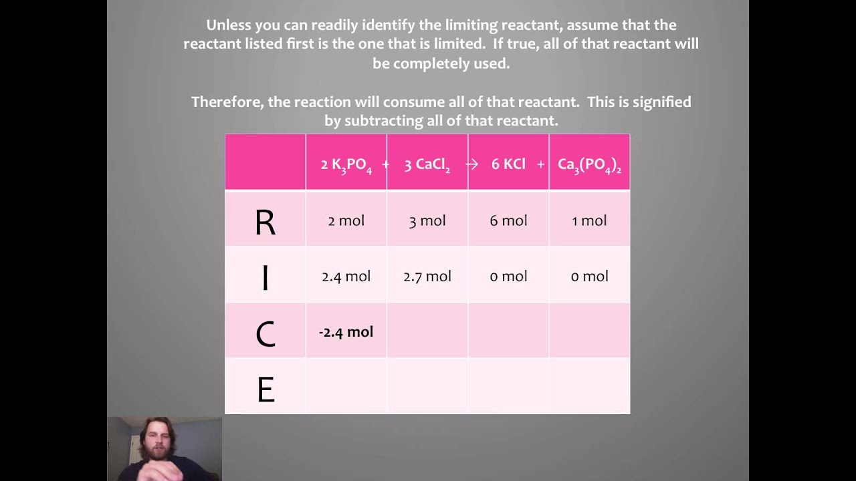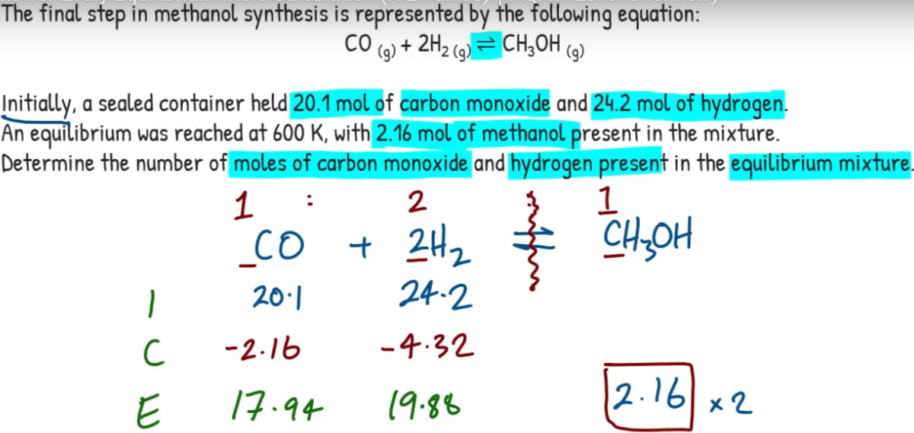  Tip: use acronym of RICE

CI.i-j - Inorganic chemistry and the periodic table | CI1 |
What is the dot cross diagram for ammonium?  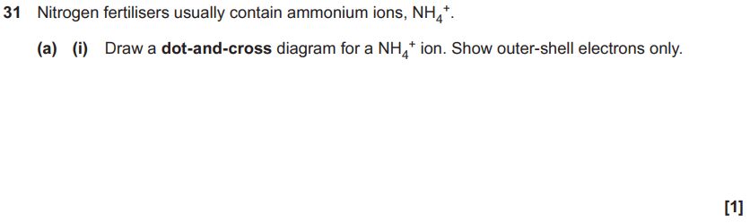 | 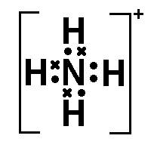  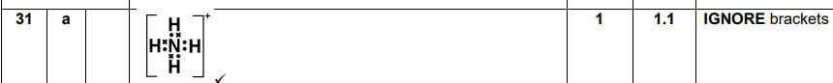
What is the systematic names for N₂O, NO and NO₂ ? | - Nitrogen(I) oxide  - Nitrogen(II) oxide  - Nitrogen(IV) oxide
What is the appearance of nitrogen(II) oxide | nitric oxide | NO |?  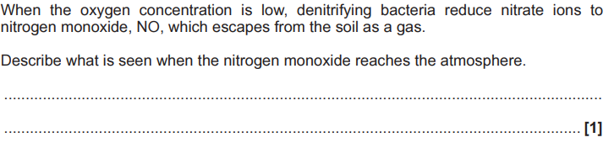 | Colourless gas  Turns to brown NO₂ in air/atmosphere VERY IMPORTANT TO REMEMBER COMES UP ALOT ON EXAM PAPERS
What is the appearance of nitrogen(IV) oxide| nitrogen dioxide | nitrous oxide | NO₂ |? | Brown gas
What is the appearance of nitrogen (I) oxide | dinitrogen oxide | dinitrogen monoxide | N₂O |? | Colourless gas
What is the oxidation state of nitrogen in NH₃, NH₄⁺ & NH₄Cl | -3
What is the test for ammonia ions?  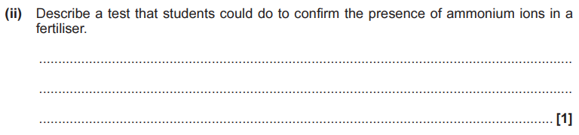 | - Add sodium hydroxide solution and heat gently  - Then hover red litmus paper over the tube and it should turn blue if NH₃ is present  [You would see dense white misty fumes due to ammonia]
What is the ionic equation for converting ammonium into ammonia?
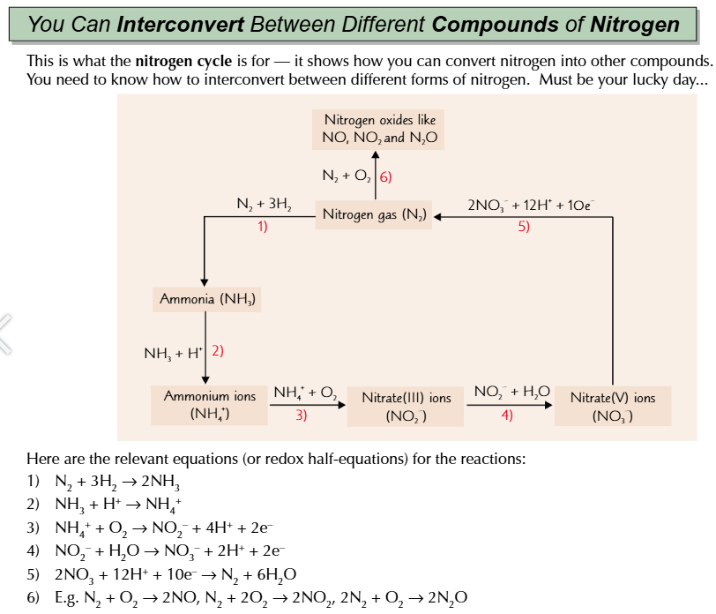

CI.k - Sustainability | CI6 |
Define co product and by-product? | - Co-product: Is a product in the same reaction as a desired product  - By-product: A product produced in a side reaction
